CSc 3320: Systems Programming

Fall 2021

Homework

# 1: Total points 100

Submission instructions:

1. Create a Google doc for each homework assignment submission.
2. Start your responses from page 2 of the document and copy these instructions on page 1.
3. Fill in your name, campus ID and panther # in the fields provided. If this information is missing in your document TWO POINTS WILL BE DEDUCTED per submission.
4. Keep this page 1 intact on all your submissions. If this *submissions instructions* page is missing in your submission TWO POINTS WILL BE DEDUCTED per submission.
5. Each homework will typically have 2-3 PARTS, where each PART focuses on specific topic(s).
6. Start your responses to each PART on a new page.
7. If you are being asked to write code copy the code into a separate txt file and submit that as well.
8. If you are being asked to test code or run specific commands or scripts, provide the evidence of your outputs through a screenshot and copy the same into the document.
9. Upon completion, download a .PDF version of the document and submit the same.

Full Name: Mohammad Osama Farhat

Campus ID: mosama1

Panther #: 002-61-6232

1. Tell the differences between Unix and Linux. Then please list some operating systems (at least three) which belong to Unix but not Linux.   
  
Ans1) Differences in Linux and Unix:

* Linux source code is available to the general public while Unix source code is not available to the public.
* Linux is portable and you can boot Linux by burning a disk or by using a USB stick while Unix is not portable.
* Linux is Open Source on the other hand Unix is not.
* Linux is written in C and other programming languages, Unix is written in C and assembly language.

Unix like that are not Linux: BSD, OSX, Solaris, etc

2. What is the pipe mechanism in UNIX? And show one command using pipe and explain how the pipe works in it?

Ans2) Pipe Mechanism is when output of one process can be used as input for another process. Using pipe mechanisms, complex tasks can be broken down into simpler ones and combined using pipes etc.  
  
For example: $ ls -la | more what this command does is it takes listing directories $ ls - l stands for list long and $ ls -la stands for list long and all which would even show the hidden files. When this happens sometimes it goes more than a whole page and it’s not possible to see everything on the page and you end up seeing some end files. When you do $ ls -la | more, it shows the output in such a way where you can use the spacebar to go to the next page and “b” to go back. We also have the $ who | sort command that i can explain but it only asks for one example.

3. In a Linux system, you can issue the command ls / to check the sub directories under root. Please describe the meanings of directory /bin, /dev, /boot, /usr, /etc, /mnt, /sbin, /var separately. For example, you can say that /bin contains binary executable files.

* ans3) /bin - contains application and binary executable commands and files
* /dev - contains all the devices that can be accessed just like any other file in the linux file system. The terminal devices such as usb or any devices connected to the system can be included under this command.
* /boot - the kernel is residing in this directory and loads up during the boot-up
* /usr - all user related applications and files are stored here. It is not necessary for system boot; basically this command contains libraries, binaries and source code for second level programming.
* /etc- contains system configuration files for example this command contains script for startup and shut down of individual programs
* /mnt- This command can be used for mount directory where sys admins can mount file system. We mount our filesystems and devices files like CD-ROM under this directory. You can then access these mounted files.
* /sbin - short for system binaries. It contains system administrative executable program files and commands that are only needed for booting, restoring, recovering and repairing the system. It’s for system administrators not for users.
* /var - variable storage directory contain data that can be changed/altered during the system runtime. It stores files generated by service like mail or log files.

4. What is the meaning of Multitask and Multi-user in a Unix system?   
  
Ans 4) Multi-user - which means it allows more than one person to use the computer resource at the same time.   
Multitask- which means Unix can perform more than one task at a time.

5. What does -rwxr-xr-x mean in terms of permissions for a file? What is the exact unix command (with the octal representation) for changing the permissions to this setting?   
  
Ans5) Given the permission setting -rwxr-xr-x

I have color coded it for better explanation. At the start of the permission setting highlighted in orange ‘-’means it’s a normal file not a directory.

r - means read  
w - means write  
x - means execute

The first part of the code ‘rwx’ which is highlighted in yellow stands for owner permission. In this the owner is given all the permissions to read write and execute

The second part of the code ‘r-x’ which is highlighted in green stands for group permission. In this the group is given only read and execute permission not to write.

The third part of the code ‘r-x’ which is highlighted in blue stands for other permission. In this everyone else is given the permission to only read and execute, They’re not given the permission to write.

We can use ‘chmod’ command to change the permission for everyone. ‘Chmod’ represents change mode.

Format of chmod command - chmod permission <filename>

For this particular code the command is - chmod 755 <filename>

6. In class, you have learned the meaning of read, write and execute permission for regular files. However, these permissions are also applied to directories. So please describe the meaning of read, write, and execute permission for directory.

Ans 6) Permissions are bit different for directories:

Read allows a user to view the directory’s content.

Write allows a user to create new files or delete files in the directory.

Execute determines if the user can enter (cd) into the directory or run a program or script.

Part II-a

Regular Expression

Find outcomes for each given basic/extended regular expression (maybe multiple correct answers)

Points per question: 2.5

|  |
| --- |
| *Example:*  *‘ab+a’* （*extended regex*）  *Answer: aba , abba ; Pattern : The matched string should begin and end with ‘a’ and ‘b’ occurs at least once between leading and ending ‘a’)* |

Note: 7) to 10) are basic regexes; Note: 11) to 18) are extended regexes.

I’ve given multiple answers for each one

7) ‘a[ab]*a’ - a) aaba, b) aaa c) ababa

8) ‘a(bc)?’ a)abc

9) ‘.[ind]*’ a) wind b) end

10) ‘[a-z]+[a-z]’ a) a) a+ b b)j+k c)c + k

11) ‘[a-z] (\+[a-z])+’ a) e+c+d b) x+a c) c+e

12) ‘a.[bc]+’ a) azbc b) axbc c)abc

13) ‘a.[0-9]’ a) ad12 b)a12 c)a52

14) ‘[a-z]+[\.\?!]’ a) great! b) good! c) worst?

15) ‘[a-z]+[\.\?!]\s*[A-Z]’ - a) car.Y b)batmobile.A c) pant.Z

16) ‘(very )+(cool )?(good|bad) weather’ a) very good weather b) very cool bad weather

17) ‘-?[0-9]+’ a) 4554 b) -4641 c) 2132

18) ‘-?[0-9]*\.?[0-9]*’ a) 4554 b) -4641 c) 0.7

Part II-b

Regular Expression

Write down the extended regular expression for following questions. E.g. Social security number in the format of 999-99-9999. Answer: [0-9]{3}-[0-9]{2}-[0-9]{4}

Points per question: 5

19) Valid URL beginning with “http://” and ending with ".edu" (e.g. http://cs.gsu.edu, http://gsu.edu)

Ans 19) /^(http):\/\/[\w\-_]+(\.[\w\-_]+)+([\w\-\.]*+(.edu)?

20) Non-negative integers. (e.g. 0, +1, 3320)

Ans 20) \+?[0-9]+

21) A valid absolute pathname in Unix (e.g. /home/ylong4, /test/try.c)

Ans 21) \/[a-z]+\/[a-z]+[0-9]\,\/[a-z]+\/[a-z]+\.[a-z]

22) Identifiers which can be between 1 and 10 characters long, must start with a letter or an underscore. The following characters can be letters or underscores or digits. (e.g. number, _name1, isOK).

Ans 22) [_a-Z]{10}

23) Phone number in any of the following format: 9999999999,999-999- 9999, (999)-999-9999. (Note: all of these formats should be matched by a single regular expression)

Ans 23) (\()*[0-9]{3}(\))*(-)*[0-9]{3}(-)*[0-9]{4}

**Part III**

**Programming**

**Points per question: 15**

24. Create a file named homework_instructions.txt using VI editor and type in it all the submission instructions from page1 of this document. Save the file in a directory named *homeworks* that you would have created. Set the permissions for this file such that only you can edit the file while anybody can only read. Find and list (on the command prompt) all the statements that contain the word POINTS. Submit your answer as a description of what you did in a sequential manner (e.g. Step1 … Step 2… and so on..). Add a screenshot to your answer as a proof of evidence.

Step 1 create directory by mkdir homeworks



Step 2 create vi homework_instructions.txt



Step 3 by first doing i to be able to type then type everything from page 1

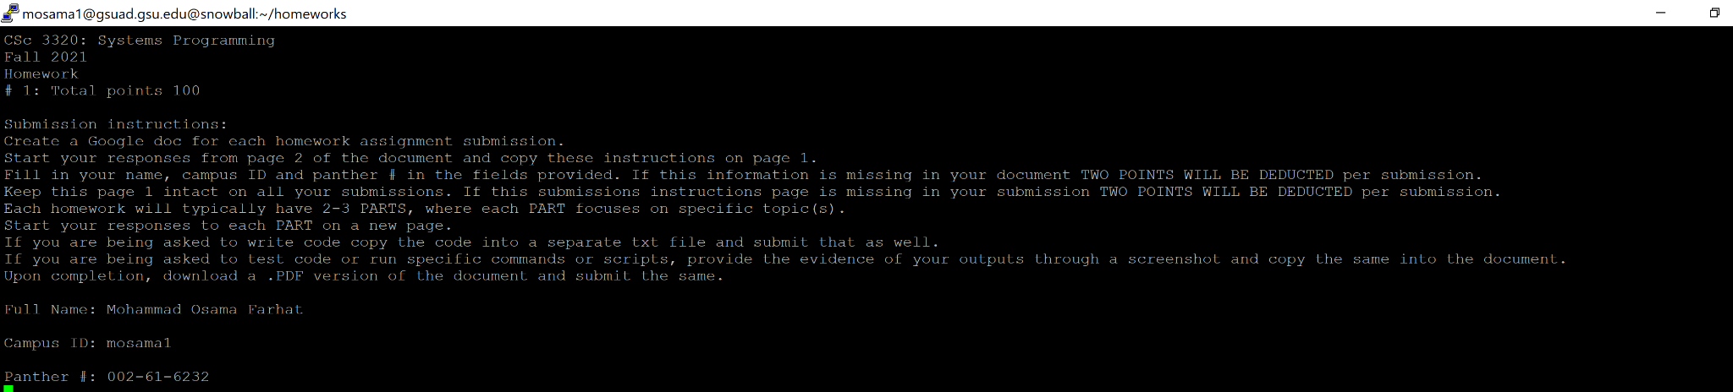

Step 4: save and exit wq

Step 5: i used egrep -e POINTS homework_instruction.txt to find POINTS

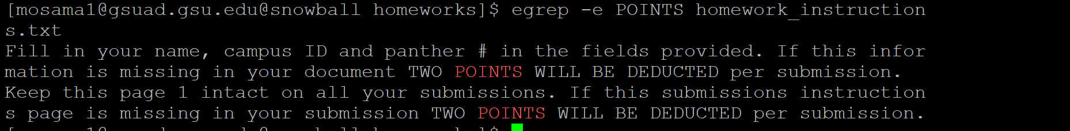

Step 6: change the file’s settings to me everything read-write-execute, while everyone else read. Chmod 744 homework_instructions.txt



Display the file screenshot attached

